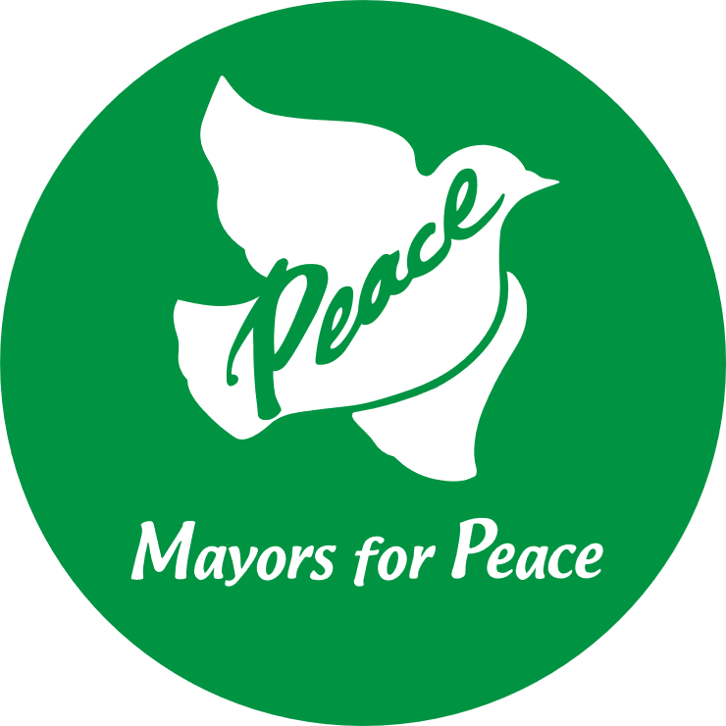
Mayors for Peace
Registration Form

To Mr. MATSUI Kazumi
Mayor of Hiroshima
President of Mayors for Peace

I hereby express my city/municipality’s support for the abolition of nuclear weapons and desire to join Mayors for Peace.*
Name of the city/municipality**:
**This is the name we will use to refer to your city/municipality in our database.
Name of country:
Mayor’s name:
Title:
Mayor’s Signature:
Date:
Mayor’s office address:

TEL: FAX:
E-mail:
Website:
Municipal Population: (as of )

Contact person
Name:
Title:
Position:
E-mail:

Questionnaire
How did you find out about Mayors for Peace?
☐Member City: (Name) ☐Ministry of Foreign Affairs of your country
☐NGO/Organization: (Name) ☐Meeting with Mayor of Hiroshima
☐Other: (please specify)

Please send this form to:
Mayors for Peace Secretariat
FAX : +81-82-242-7452
E-mail : mayorcon@pcf.city.hiroshima.jp

Note

*This registration form implies your city/municipality’s decision to join Mayors for Peace. If your city/municipality requires specific procedures, including approval from your city/municipal council, please submit this form after such procedures are completed.

*Mayors for Peace runs several social media sites (Twitter @Mayors4Peace, Facebook @mayorsforpeace) where we would like to introduce our new member cities. We ask your permission to share information about your new membership with our followers. If you agree to the above, we ask that you please provide (1) a photo of the current mayor and (2) a photo that represents your city (landmark, landscape, etc.). Thank you in advance for your cooperation.

