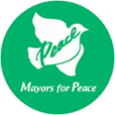
Application Form for the Youth Exchange for Peace:
Form 1
Support Program for “HIROSHIMA and PEACE”

Our city hereby applies to the Youth Exchange for Peace: Support Program for “HIROSHIMA and PEACE” on behalf of the following applicant:

- Applicant Information
Name

2. Member City Information
(1) Information of the sponsoring member city/municipality/other local government entity
City Name |  | Country
Mayor’s Name

(2) City contact information
Name of the contact person
Position
Department
Email
Address
Phone |  | Fax

